**HOW TO RUN SIMBA AND SKETCH**

1. Extract the folder SIMBA.zip
2. Open the folder SIMBA. It has the following contents as shown in the image below.

1. Run SIMBA.exe

1. Draw articulated product concept (planar mechanism). Here a 4-bar mechanism is illustrated. Left-click on the Draw option and drag the mouse cursor in the workspace below the tab as shown in Figure below. By default, the canvas is the ground link.A screen shot of a computer

   Description automatically generated
2. Go to Build tab for adding joints. Left click on the rotary joints. Use right-click to draw the rotary joints.

1. Choose suitable values for force and velocity. Then, choose an appropriate joint for simulation by left-click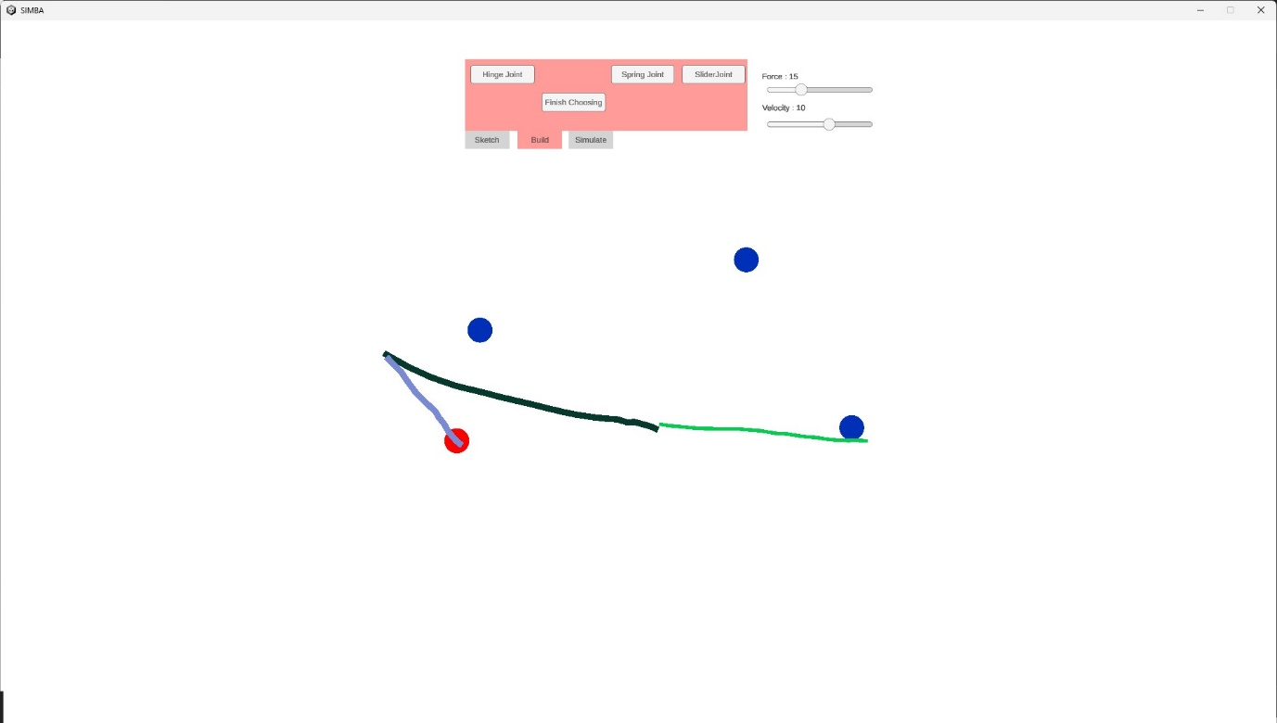
2. For other features, you can refer to other videos in the folder Supplementary material